Cell Phone Project: 2

Ben Parsell

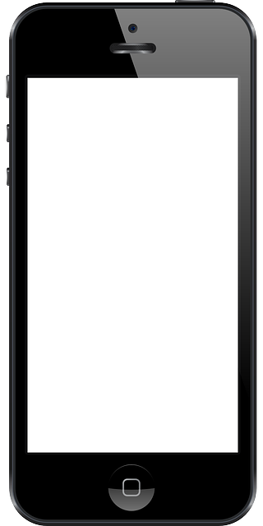

"I pledge that this work is entirely mine, and mine alone (except for any code provided by my instructor)."

“I spent 12 hours on this project from the date assigned, until October 13th. During this period I spent time creating algorithms, writing code, styling code, and smashing bugs. I worked with Ryan Walt on small bug issues.”

MyPhone Monthly Statement

Customer: Amanda Jaffe

Number: (123)456-789

Texts: 2

Data usage: 3.5 GB

2GB Plan: $50.00

Additional data fee: $30.0

Universal Usage (3%): $2.4

Administrative Fee: $0.61

Total Charges: $83.01